Sonia Jaidka (sj586)

CHEME 5440

Final Exam

May 22, 2020

**Question 1**

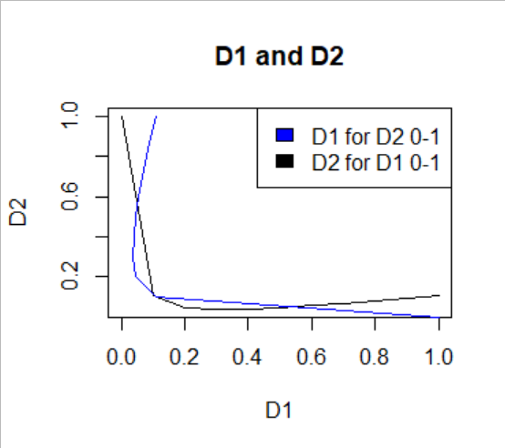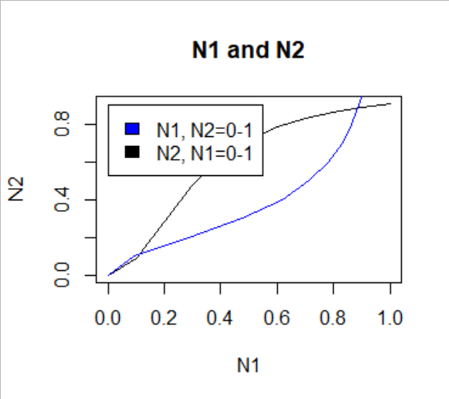

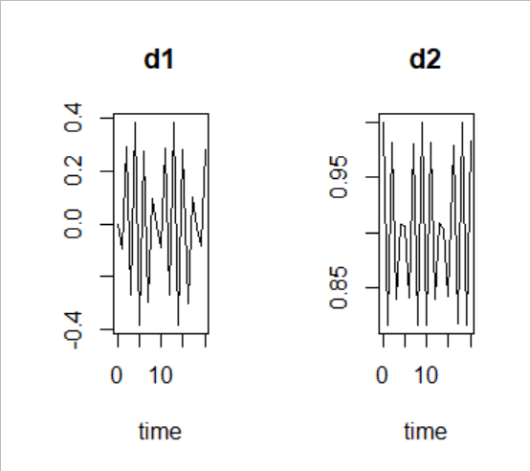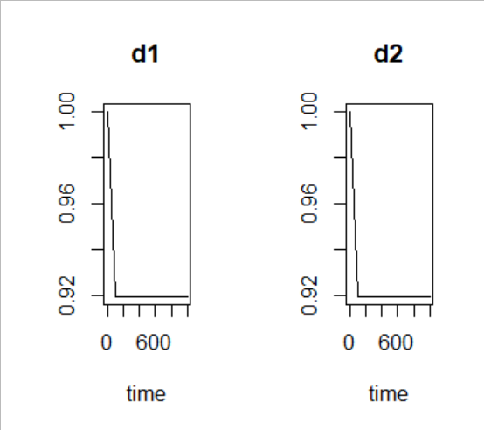

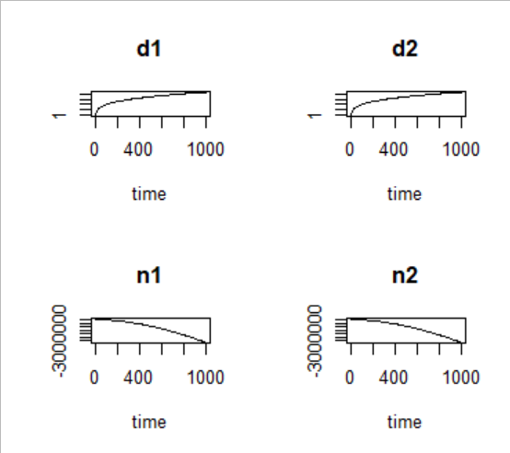

Discussion:

I had trouble making a phase portrait, so I have provided plots of D1 and D2 just like in the lecture notes as well as the derivatives for D1 and D2 over time. I also provided plots of N1 and N2, and I included phase portrait code to the best of my ability in the scripts I used. The plot to the left shows what happens when the system has some D1 but no D2, and the plot on the right shows how both relax to steady state when the system has D1 and D2. I used two scripts to calculate values of D1, D2, N1, and N2.

Given this information, lateral inhibition in the case where the decay rate of Notch is much greater than the decay rate of Delta works differently from the opposite case where the decay rate of Delta is much greater than the decay rate of Notch. Since Notch is activated by Delta, if Notch degrades faster than Delta, it makes sense that the amount of Notch in the system will ready a steady state value where it is changing slower than the amount of Delta. You can see from the plot of N1 and N2 that it is shaped similarly to the plot from the lecture notes, but the curves are slightly skewed and facing the opposite direction. You can also see from the plots of d1, d2, n1, and n2, that N1 and N2 eventually reach a steady state value.

**Question 2**

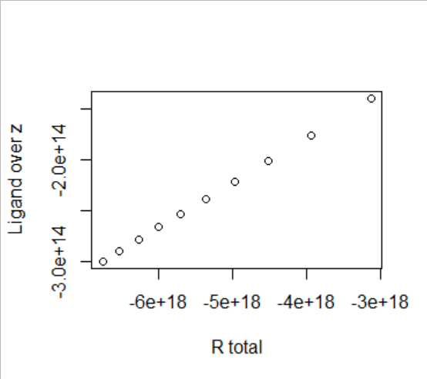

**Question 3**

|  |  |  |  |
| --- | --- | --- | --- |
| Parameter | Value | Units | Source |
| ex, polymerase elongation rate | 42 | nt/s | BioNumbers 108487  Proshkin S, Rahmouni AR, Mironov A, Nudler E. Cooperation between translating ribosomes and RNA polymerase in transcription elongation. Science. 2010 Apr 23 328(5977):504-8. p.505 table 1**PubMed ID**[20413502](https://bionumbers.hms.harvard.edu/redirect.aspx?pbmid=20413502&hlid=) |
| Rx,T, total RNAP | 2000 | RNAP/cell | BioNumbers 113766  Ishihama A. 1981. Subunit assembly of Escherichia coli RNA polymerase. Adv. Biophys. 14: 1–35 [43] Ishihama A, Taketo M, Saitoh T, Fukuda R. 1976. Control of formation of RNA polymerase in Escherichia coli. In RNA Polymerase, ed. M Camberlin, R Losick, pp. 475–502. Cold Spring Harbor, NY: Cold Spring Harbor Lab. Press**PubMed ID**[7015808](https://bionumbers.hms.harvard.edu/redirect.aspx?pbmid=7015808&hlid=) |
| Gj, gene concentration | 0.94 | genes/kb | BioNumbers 105751  Rogozin IB, Makarova KS, Natale DA, Spiridonov AN, Tatusov RL, Wolf YI, Yin J, Koonin EV. Congruent evolution of different classes of non-coding DNA in prokaryotic genomes. Nucleic Acids Res. 2002 Oct 1 30(19):4264-71. p.4266 table 1 Table - [link](http://bionumbers.hms.harvard.edu/files/Various%20statistics%20of%20prokaryotic%20genomes.pdf) **PubMed ID**[12364605](https://bionumbers.hms.harvard.edu/redirect.aspx?pbmid=12364605&hlid=) |
| genome size | 4,639,221 | bp | BioNumbers 100269 Blattner FR et al, The complete genome sequence of Escherichia coli K-12. Science. 1997 Sep 5 277(5331):1453-74. p.1454 right column 4th paragraph**PubMed ID**[9278503](https://bionumbers.hms.harvard.edu/redirect.aspx?pbmid=9278503&hlid=) |
| translation rate | 14 | aa/s | BioNumbers 108487  Proshkin S, Rahmouni AR, Mironov A, Nudler E. Cooperation between translating ribosomes and RNA polymerase in transcription elongation. Science. 2010 Apr 23 328(5977):504-8. p.505 table 1**PubMed ID**[20413502](https://bionumbers.hms.harvard.edu/redirect.aspx?pbmid=20413502&hlid=) |
| kI | 0.012-0.11 | s-1 | BioNumbers 105132  Buc H, McClure WR. Kinetics of open complex formation between Escherichia coli RNA polymerase and the lac UV5 promoter. Evidence for a sequential mechanism involving three steps. Biochemistry. 1985 May 21 24(11):2712-23. p.2717 table II**PubMed ID**[3896304](https://bionumbers.hms.harvard.edu/redirect.aspx?pbmid=3896304&hlid=) |
| mRNA degradation | 3-8 | min | BioNumbers 108598  Bakshi S, Siryaporn A, Goulian M, Weisshaar JC. Superresolution imaging of ribosomes and RNA polymerase in live Escherichia coli cells. Mol Microbiol. 2012 Jul85(1):21-38. doi: 10.1111/j.1365-2958.2012.08081.x. p.22 right column top paragraph**PubMed ID**[22624875](https://bionumbers.hms.harvard.edu/redirect.aspx?pbmid=22624875&hlid=) |

*Part B*

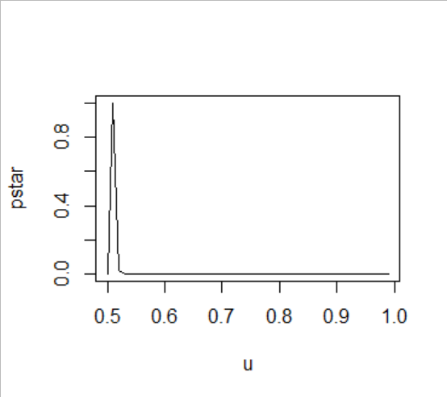

*Part C*

